



**The Grizzly Badgers,**

**Singapore Management University**

**Ang Mo Kio - Thye Hua Kwan Hospital**

**Functional Specifications**

**Visitor Registration Module**

**Stepwise**

**v1.0**

**9 December 2016**

**Revision History**

|  |  |  |  |  |  |
| --- | --- | --- | --- | --- | --- |
| **Version** | **Effective Date** | **Summary of Change** | **Prepared by** | **Reviewed by** | **Approved by** |
| 1.0 | 09/12/2016 | Initial Version | Yu Zheng Yuan |  |  |
|  |  |  |  |  |  |

Contents

1) Introduction 4

2) Overview of Administration Module 4

3) Functional Requirements 4

4) Process and Business Rule 5

5) Error and Message Handling 6

Appendices 7

## Introduction

* 1. We aim to include an administration the existing visitor registration process by reducing the amount of manual tasks needed to capture the visitor information.

## Overview of Administration Module

* 1. Visitors will now have the option to register their visit online before they enter the hospital. It will reduce the time needed to queue up and it reduces the workload for the front desk staff as they will now only be required to help take the visitor’s temperature and check if the ward’s visiting capacity is at a reasonable limit to enter.

## Functional Requirements

* 1. Stepwise Administration Module provides the following key functions to facilitate the registration of visitor:
     1. Visitor Online Self-Registration / Assisted Registration
        1. The Visitor Online Self-Registration will be a website that is accessible on the hospital’s website for visitors to register their visit online. But if visitors do not register beforehand, the front desk staff would be able to do so by helping to register a new visit by the assisted registration page.

## Process and Business Rule

* 1. **Process Flow for Adminstration**

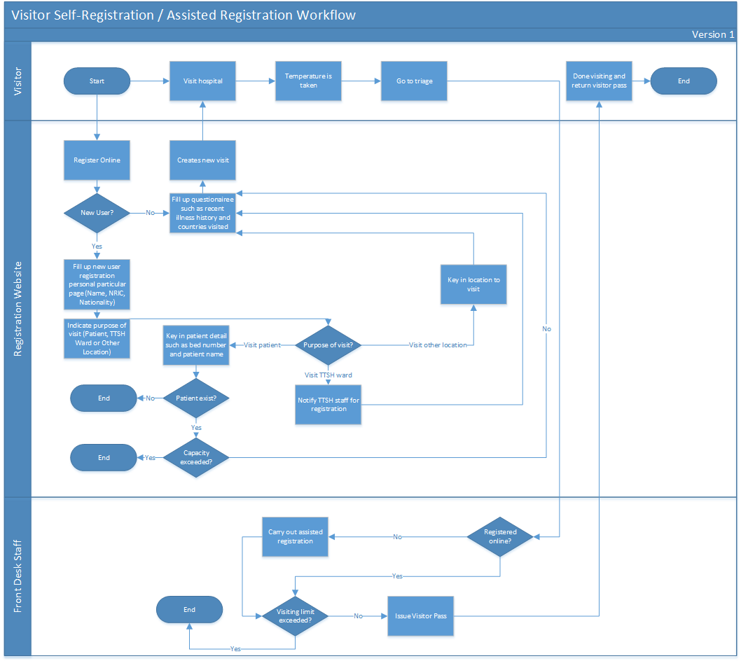

..\Documents\RegistrationWorkflow.pdf

## Error and Message Handling

| **Error Code** | **Error Message** | **Remarks** |
| --- | --- | --- |
| 1001 | System Error. Please contact the system administrator. |  |
| 1002 | This item is mandatory. |  |
| 1003 | Invalid NRIC/FIN number. |  |
| 1005 | Please enter valid Contact Number. |  |
| 1006 | Please enter Mobile Number in digits. |  |
| 1007 | Patient information is wrong |  |

## Appendices

|  |
| --- |
| **Screen 1.1 Administration Window** |
|  |

|  |  |  |  |  |  |  |  |
| --- | --- | --- | --- | --- | --- | --- | --- |
| **Table 1.1 Data Fields for Administration Window** | | | | | | | |
| **Name** | **UI Element Type** | **Size** | **Mandatory?** | **Default** | **Format** | **Validation** | **Error Message** |
| Name | Textbox | - | N | - | Varchar | No validation | - |
| NRIC/FIN | Textbox | - | Y | - | Varchar | Valid NRIC/FIN number | 1003 |
| Mobile Number | Textbox | - | Y | - | Number | Valid mobile number | 1006 |
| Patient Name | Textbox | - | Y | - | Varchar | Valid patient | 1007 |
| Patient Ward | Dropdown | - | Y | - | Varchar | Valid ward | 1007 |
| Patient Bed Number | Dropdown | - | Y | - | Varchar | Valid bed number | 1007 |
| Date | Calendar | - | N | - | Date | - | - |
| Visiting Time | Time | - | N | - | Time | - | - |
| Submit | Button | - | - | - | - | - | - |
| Cancel | Button | - | - | - | - | - | - |